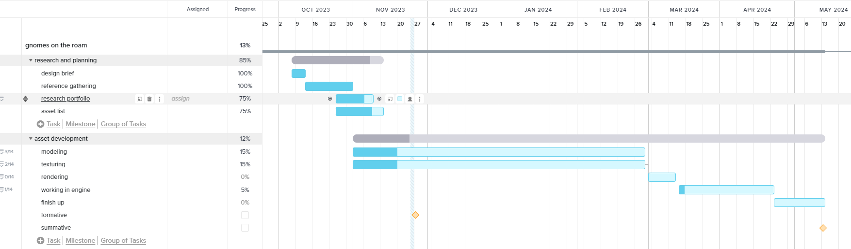

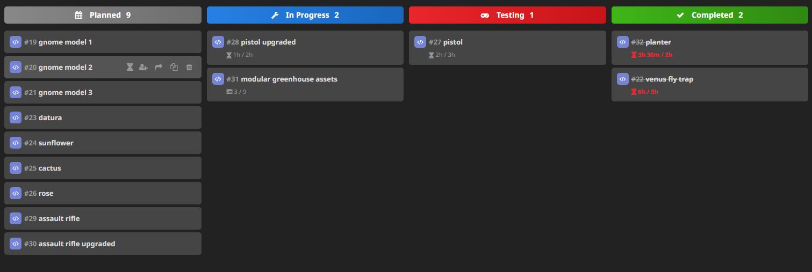

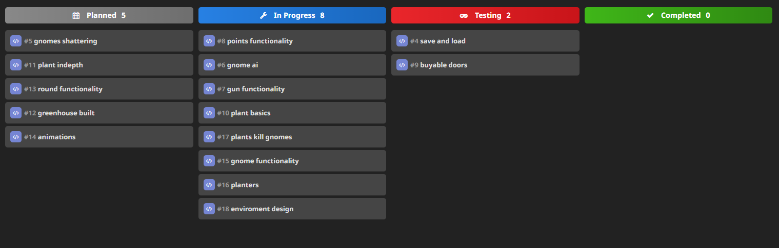

For my time management I decided to use a combination of both a Gantt chart and 2 Kanban boards. I chose to do this because both methods have positives and negatives when using them for game development projects. I decided to use the Gantt chart to have an overall plan for when I should be working on key parts of the project, the line-based overview is very useful for time management as its clear how long is dedicated to each part of the project. It also allows me to have an overall percentage of the completion in each part of the project.

Whilst Gantt charts are very useful for time management I find it is not as useful when attempting to manage smaller parts of each segment, for example while you can make a list of tick boxes to track progress on each individual model its not as easy to tell at a glance what part of development each model is at.

This is a problem that I have worked around by also using Kanban charts, I find Kanban charts are useful to manage smaller parts of the projects such as each individual model. Progress on each model can be easily understood with just a quick glance, I also find it helps keep my morale higher as I can see things moving around and visually tell how much I have progressed at a time. I also find it very useful as I can quickly look at the chart and see what models I am currently working on and where in development they are which helps me manage my time better as when It allows me to sit down before I start working and have some clear objectives to reach by the end of the day.

The software I am using for my Kanban chart is HackNPlan despite being very helpful there are downsides to the software. One downside I have encountered in working is that it does not allow me to rename the headings at the top of the chart, since these cannot be changed while working on parts of the project that don’t follow those headings such as modelling I have to mentally rename these headings. For example, on my asset development Kanban chart instead of “testing” I think of it as texturing so once my model has been modelled and is ready to be textured I can move it into the testing column. I also find it difficult to get a good overview of the entire project while using a Kanban I struggle to tell how far into the project I am whilst this is inconvenient I still find the Kanban chart a very useful time management tool that helps me keep track of the parts of the project.

The combination of using both helps counteract the downsides of using each one individually. For overlooking the entire project and managing the larger parts of the time management plan I am using teamGantt as that is where I feel it is best used and for the smaller parts of the management plan such as each individual asset im using HackNPlan.